GROCERY DEMAND FORECASTING
A project report submitted in fulfillment of the requirement for the
degree of B.Tech.
Prajakta Utage [E23CSEU0438]
Batch-15
Under the supervision of Dr. Manoj Kumar



Bennett University,Greater Noida
Session 2024-2025
November, 2025

DECLARATION
We confirm that this submission is our own work and that, to the best of our knowledge and belief, it contains no material previously published or written by another person nor material which to a substantial extent has been accepted for the award of any other degree or diploma of the university or other institute of higher learning, except where due acknowledgment has been made in the text.
Name : Prajakta Utage
Roll No. : E23CSEU0438
Date : 19/11/2025

This is to certify that the Project Report entitled “Grocery Demand Forecasting” which is submitted by Prajakta Utage in partial fulfillment of the requirement for the award of degree B. Tech. in the Department of Information Technology of Bennett University, is a record of the candidate's own work carried out by him under my/our supervision. The matter embodied in this report is original and has not been submitted for the award of any other degree.
Supervisor: Dr. Manoj Kumar
(Associate Professor Dept. of IT)

ACKNOWLEDGEMENT
It gives us a great sense of pleasure to present the report of the B. Tech Project undertaken during B. Tech. 3rd year. We owe a special debt of gratitude to Mr. Manoj Kumar, Department of Information Technology, Bennett University, Greater Noida for his constant support and guidance throughout the course of our work. His sincerity, thoroughness, and perseverance have been a constant source of inspiration for us. It is only his cognizant efforts that our endeavors have seen the light of the day.. We also do not like to miss the opportunity to acknowledge the contribution of all faculty members of the department for their kind assistance and cooperation during the development of our project. Last but not the least, we acknowledge our friends for their contribution to the completion of the project.

Abstract
This project focuses on forecasting retail product demand in India using time-series analysis and predictive modeling techniques. The dataset is from Kaggle and it has 2,534 retail transaction records from 2010 to 2013 including features like order date, product type, sub-category, sales, profit, discount, freight mode, and quantity ordered. The study does both daily and monthly forecasting. Daily demand forecasting performed using ARIMA, SARIMA, and Holt Winters models and monthly forecasting is performed for each product type and sub-category combination using SARIMAX, ETS, and fallback seasonal averaging.
Preprocessing includes date conversion, grouping, resampling, and handling missing values. The models are evaluated using RMSE, MAE, and MAPE. Results show that SARIMA performs best for daily demand with the lowest RMSE (38.85). On monthly level the model selects the most suitable model per product group and generates forecasts extending up to 2014 onwards. The project tells the use of classical forecasting techniques for retail analytics and also supports inventory management, logistics planning, and data driven decision making.

Introduction
Forecasting product demand plays a crucial role in the retail industry specially in a dynamic and fast expanding market like India. With increasing competition, diverse customer preferences, and complex supply chain networks, they must predict future demand accurately to maintain optimal inventory levels and deliver high service quality. In Indian retail where seasonal festivals, regional buying patterns, and price-sensitive consumer behavior significantly influence sales the ability to forecast demand with precision becomes even more important.
Effective demand forecasting helps businesses balance two critical aspects i.e minimizing excess inventory costs and preventing stockouts. Overstocking leads to capital blockage and higher storage expenses while understocking results in lost sales. dissatisfied customers, and potential brand damage. Developing a robust forecasting system enables retailers replenishment planning, improve supply chain coordination, optimize procurement cycles, and ultimately enhance customer satisfaction.
This project focuses on analyzing historical transaction data to uncover meaningful sales patterns and trends. By leveraging classical time-series forecasting techniques including ARIMA, SARIMA, and Holt Winters Exponential Smoothing the project aims to build reliable prediction models that can estimate future product demand at both daily and monthly levels. These traditional models remain highly relevant due to their interpretability, versatility, and strong performance in structured time series environments.
The primary objectives of this work include:-
- Understanding sales patterns by identifying trends, seasonality, and demand fluctuations across products.
- Applying well established forecasting models such as ARIMA, SARIMA, and Holt Winters to generate accurate demand predictions.
- Evaluating and comparing model performance through statistical metrics to determine the best fit method for each product.
- Generating product wise monthly forecasts that retailers can directly use for operational planning, procurement scheduling, and inventory optimization.
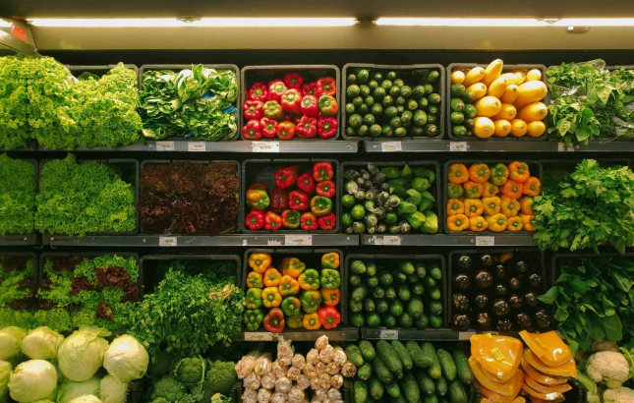
Literature Review
- Box & Jenkins (1976) introduced ARIMA modelling is used for time series forecasting when seasonality and trends are present.
- Holt (1957) and Winters (1960) proposed the Holt-Winters exponential smoothing model which performs nicely for seasonal retail and economic data.
- Hyndman & Athanasopoulos (2018) demonstrated the usefulness of ETS and SARIMA models in retail forecasting for automated selection for better accuracy.
- Makridakis et al. (2020) compared classical and ml forecasting techniques in the M competitions showing that traditional models don’t perform good for ML models for short seasonal data.
- Recent studies using retail datasets from Kaggle and UCI repositories focus on the need for product level forecasting yet such works often ignore dynamic model selection per product group.
Gap addressed: This project combines both daily and per product monthly forecasting, automatically selecting the best model for each product or sub category, which many prior studies do not address.

Dataset Description & Preprocessing
Dataset from: - Kaggle: – India Retail Transactions Dataset
Size: 2,534 records
Time Period: 2010–2013
Key Features are:-
- Order Date, Ship Date
- Product Type, Product Sub-Category
- QtyOrdered (target variable)
- Sales, Profit
- Discount offered, Unit price
- State, City, Region, Freight Mode
Preprocessing Steps:
- Convert Order Date to datetime.
- Sorted data in order.
- Daily demand: -grouped by date and filled missing days using asfreq('D') and linear interpolation.
- Monthly demand:- aggregated by Year Month for each product type and sub category.
- Missing monthly records id handled by reindexing and also filling zero values.

Methodology
Models Used are:-
Daily Forecasting:
- ARIMA (1,1,1)
- SARIMA (1,1,1)(1,1,1,12)
- Holt Winters (Additive Seasonality)
Monthly Product Wise Forecasting:
- SARIMAX (seasonal forecasting)
- ETS (Exponential Smoothing)
- Seasonal mean fallback
- Last value fallback for short series
Training & Testing:-
- 80–20 time-based split
- Evaluated using RMSE, MAE, MAPE
Workflow:-
- Load dataset
- Clean and preprocess
- Daily trend modeling
- Group dataset by product type × sub-category
- Train SARIMAX/ETS automatically
- Evaluate and compare
- Generate forecasts up to 2014 and save outputs
Tools:-
Python, Pandas, NumPy, Statsmodels, Scikit-Learn, Matplotlib, Seaborn

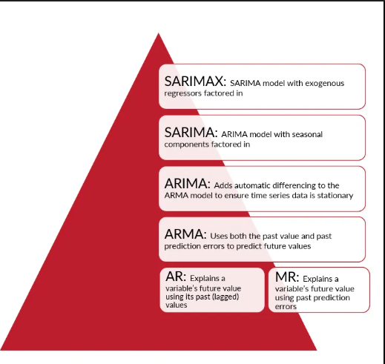

Daily Forecast Results

Table 1 accuracy
Model | RMSE | MAE | MAPE
ARIMA | 39.09 | 27.19 | 184.41%
SARIMA | 38.85 | 29.97 | 243.64%
Holt-Winters | 41.55 | 26.61 | 134.04%

SARIMA delivers the lowest RMSE, making it best for reducing large errors. Holt Winters shows the best MAPE. Daily forecasts show visible seasonality consistent with retail patterns.
Monthly Forecast Results:
- Model selection varies per product group.
- Many groups successfully fit SARIMAX; others use ETS or fallback models.
- Future forecasts up to 2014 onward were generated and saved.
Insights:
- Retail demand shows strong seasonal patterns.
- Classical models perform well even with limited monthly data.
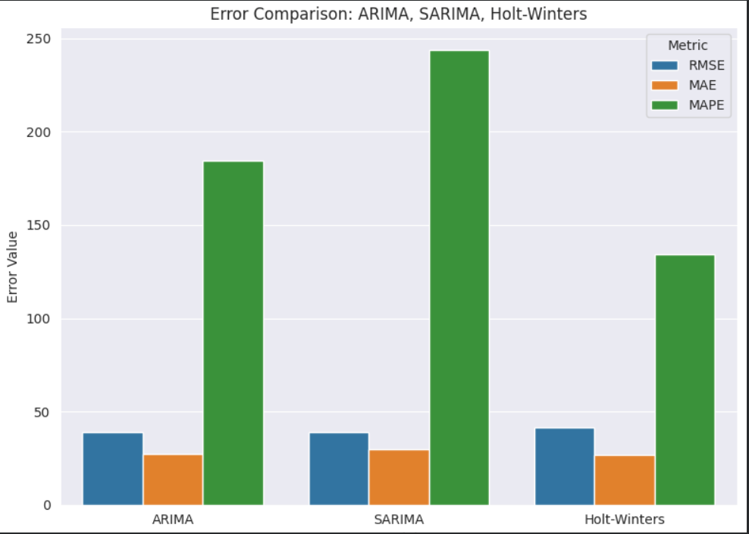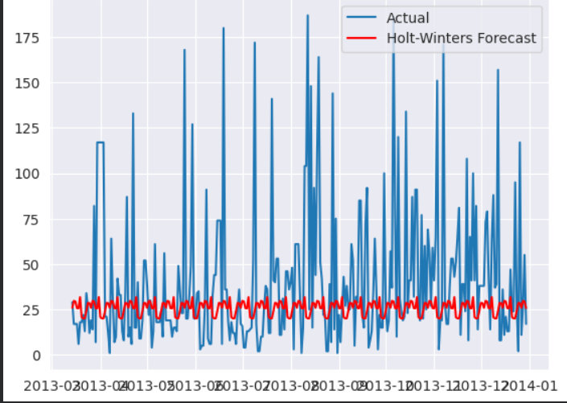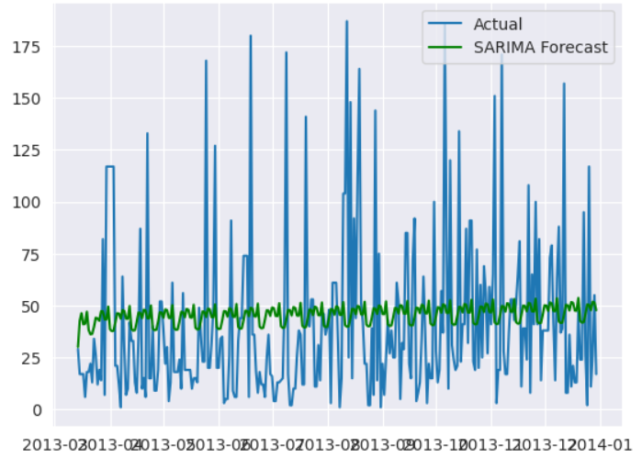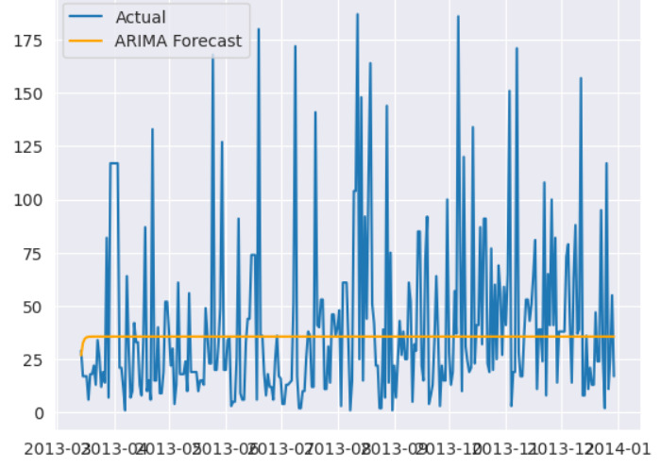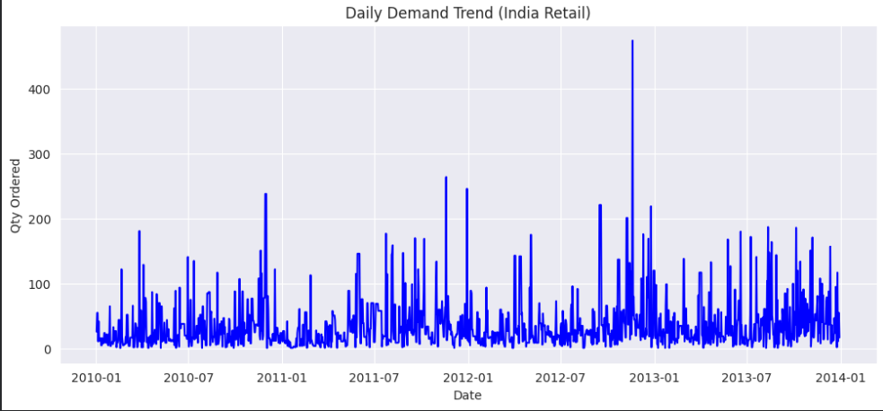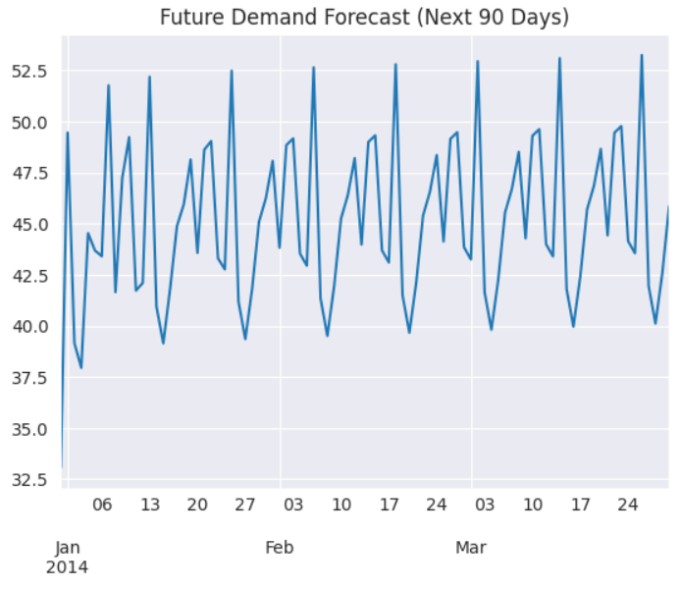

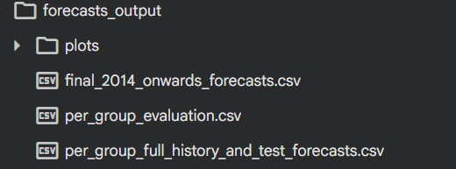

Conclusion & Future Work

This project explains that classical models such as SARIMA and Holt Winters provide reliable demand forecasting for retail datasets. SARIMA performed best for daily predictions, while an automated hybrid approach allowed per product monthly forecasting. The system supports data driven decision making in inventory control, supply chain planning, and sales strategy. Limitations are lack of external factors such as promotions or competitor activity. Future work can integrate machine-learning models like LSTM or Prophet, incorporate external regressors, build a forecasting dashboard, and deploy as a scalable web API.
References
- Box, G. E., & Jenkins, G. M. (1976). Time Series Analysis: Forecasting and Control.
- Holt, C. C. (1957). Forecasting seasonals and trends by exponentially weighted moving averages.
- Winters, P. R. (1960). Forecasting sales by exponentially weighted moving averages.
- Hyndman, R. J., & Athanasopoulos, G. (2018). Forecasting: Principles and Practice.
- Makridakis, S., Spiliotis, E., & Assimakopoulos, V. (2020). The M4 Competition. IJF.
- Kaggle Dataset – India Retail Dataset.
- Chatfield, C. (2003). The Analysis of Time Series.
- Brockwell, P., & Davis, R. (2016). Introduction to Time Series and Forecasting.
- Montgomery, D. C., Jennings, C. L., & Kulahci, M. (2015). Introduction to Time Series Analysis and Forecasting.
- Box-Steffensmeier, J. M. (2008). Time-series models and forecasting.

